Usage Statistics for snydersstoughton.com
Summary Period: Last 12 Months
Generated 14-Sep-2009 01:19 EDT

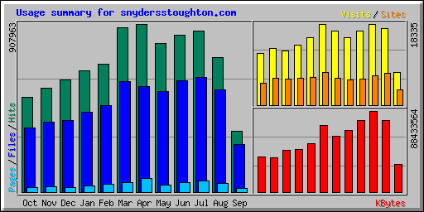
Summary by Month
Month | Daily Avg |  |  |  | Monthly Totals
Month | Hits | Files | Pages | Visits | Sites | KBytes | Visits | Pages | Files | Hits
Sep 2009 | 23604 | 18429 | 1474 | 522 | 3494 | 30243231 | 7320 | 20645 | 258006 | 330462
Aug 2009 | 23383 | 17787 | 1510 | 556 | 7145 | 78233999 | 17245 | 46813 | 551409 | 724874
Jul 2009 | 28009 | 19969 | 2001 | 588 | 6635 | 88433564 | 18242 | 62060 | 619055 | 868283
Jun 2009 | 28255 | 20039 | 1717 | 557 | 5889 | 77617336 | 16723 | 51532 | 601175 | 847664
May 2009 | 25912 | 17498 | 1284 | 489 | 5644 | 67135667 | 15187 | 39823 | 542454 | 803277
Apr 2009 | 30265 | 19052 | 2481 | 555 | 6066 | 60482274 | 16660 | 74450 | 571573 | 907963
Mar 2009 | 28633 | 19299 | 1731 | 591 | 7479 | 72232841 | 18335 | 53662 | 598272 | 887653
Feb 2009 | 24733 | 16679 | 1458 | 541 | 6225 | 53205707 | 15159 | 40840 | 467030 | 692548
Jan 2009 | 21206 | 13882 | 1070 | 438 | 6016 | 46379717 | 13597 | 33188 | 430348 | 657401
Dec 2008 | 19576 | 12551 | 841 | 395 | 5914 | 45176554 | 12263 | 26088 | 389097 | 606880
Nov 2008 | 18680 | 12594 | 963 | 428 | 6160 | 37718591 | 12857 | 28906 | 377841 | 560426
Oct 2008 | 16491 | 11145 | 850 | 378 | 4913 | 38572479 | 11723 | 26365 | 345521 | 511234
Totals |  |  |  |  |  | 695431960 | 175311 | 504372 | 5751781 | 8398665

Generated by Webalizer Version 2.01

