Usage Statistics for snydersstoughton.com
Summary Period: Last 12 Months
Generated 02-Jul-2008 15:00 EDT

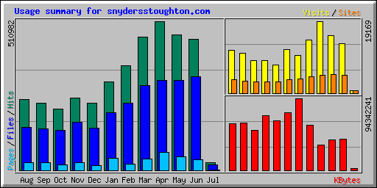
Summary by Month
Month | Daily Avg |  |  |  | Monthly Totals
Month | Hits | Files | Pages | Visits | Sites | KBytes | Visits | Pages | Files | Hits
Jul 2008 | 13025 | 8990 | 741 | 339 | 672 | 2031761 | 678 | 1482 | 17980 | 26051
Jun 2008 | 15001 | 10662 | 1247 | 438 | 4879 | 40571509 | 13164 | 37433 | 319874 | 450039
May 2008 | 15009 | 9954 | 1472 | 495 | 4994 | 39656455 | 15372 | 45648 | 308596 | 465293
Apr 2008 | 17032 | 10289 | 2027 | 638 | 4831 | 33410770 | 19169 | 60831 | 308677 | 510982
Mar 2008 | 14718 | 9412 | 1275 | 460 | 4358 | 58775996 | 14278 | 39543 | 291786 | 456284
Feb 2008 | 12368 | 7971 | 723 | 345 | 3739 | 94342241 | 10026 | 20982 | 231187 | 358699
Jan 2008 | 10124 | 6605 | 1389 | 389 | 3679 | 75359564 | 11688 | 41681 | 198167 | 303728
Dec 2007 | 7637 | 4859 | 514 | 247 | 2943 | 64538308 | 7436 | 15443 | 145773 | 229119
Nov 2007 | 8550 | 5697 | 949 | 297 | 3049 | 72006158 | 8627 | 27537 | 165235 | 247964
Oct 2007 | 7025 | 4541 | 669 | 288 | 3053 | 52940905 | 8660 | 20071 | 136256 | 210773
Sep 2007 | 7909 | 4930 | 910 | 365 | 3176 | 62152122 | 10594 | 26395 | 142975 | 229366
Aug 2007 | 7866 | 4750 | 892 | 366 | 3547 | 61208386 | 11357 | 27681 | 147252 | 243875
Totals |  |  |  |  |  | 656994174 | 131049 | 364727 | 2413758 | 3732173

Generated by Webalizer Version 2.01

