Usage Statistics for snydersstoughton.com
Summary Period: Last 12 Months
Generated 10-May-2010 01:20 EDT

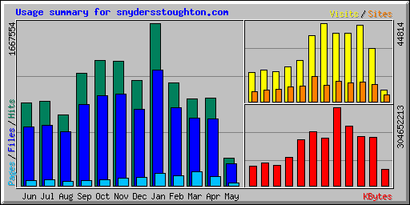
Summary by Month
Month | Daily Avg |  |  |  | Monthly Totals
Month | Hits | Files | Pages | Visits | Sites | KBytes | Visits | Pages | Files | Hits
May 2010 | 28346 | 22533 | 2774 | 671 | 3756 | 62798782 | 6712 | 27742 | 225334 | 283467
Apr 2010 | 30101 | 22836 | 3103 | 1009 | 10034 | 188036572 | 30284 | 93117 | 685095 | 903047
Mar 2010 | 28733 | 22273 | 4552 | 1413 | 11062 | 189934460 | 43810 | 141126 | 690479 | 890729
Feb 2010 | 37695 | 28527 | 3718 | 1396 | 10837 | 231937051 | 39108 | 104125 | 798779 | 1055470
Jan 2010 | 53792 | 38409 | 4063 | 1260 | 11531 | 304652213 | 39079 | 125981 | 1190687 | 1667554
Dec 2009 | 34908 | 25328 | 2791 | 1445 | 9244 | 183659700 | 44814 | 86547 | 785196 | 1082160
Nov 2009 | 42651 | 31474 | 2510 | 1258 | 14602 | 208497587 | 37747 | 75300 | 944222 | 1279533
Oct 2009 | 41460 | 29712 | 1894 | 752 | 9102 | 178337175 | 23324 | 58744 | 921087 | 1285276
Sep 2009 | 38445 | 27850 | 1829 | 655 | 8529 | 111814873 | 19673 | 54891 | 835512 | 1153367
Aug 2009 | 23383 | 17787 | 1510 | 556 | 7145 | 78233999 | 17245 | 46813 | 551409 | 724874
Jul 2009 | 28009 | 19969 | 2001 | 588 | 6635 | 88433564 | 18242 | 62060 | 619055 | 868283
Jun 2009 | 28255 | 20039 | 1717 | 557 | 5889 | 77617336 | 16723 | 51532 | 601175 | 847664
Totals |  |  |  |  |  | 1903953312 | 336761 | 927978 | 8848030 | 12041424

Generated by Webalizer Version 2.01

