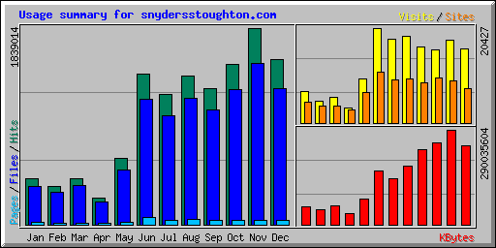
Summary by Month
Month | Daily Avg |  |  |  | Monthly Totals
Month | Hits | Files | Pages | Visits | Sites | KBytes | Visits | Pages | Files | Hits
Dec 2011 | 59372 | 49055 | 1524 | 609 | 7391 | 239942708 | 15855 | 39638 | 1275430 | 1543683
Nov 2011 | 61300 | 50343 | 1483 | 590 | 9008 | 290035604 | 17721 | 44490 | 1510311 | 1839014
Oct 2011 | 48442 | 40734 | 1188 | 509 | 9594 | 249890525 | 15807 | 36850 | 1262768 | 1501702
Sep 2011 | 42410 | 35764 | 1506 | 547 | 8548 | 228065500 | 16424 | 45191 | 1072932 | 1272323
Aug 2011 | 44926 | 38022 | 1533 | 601 | 9535 | 177848943 | 18661 | 47529 | 1178709 | 1392713
Jul 2011 | 39345 | 32778 | 1339 | 580 | 9360 | 141916226 | 17986 | 41539 | 1016129 | 1219702
Jun 2011 | 47001 | 39250 | 2321 | 680 | 10841 | 165392055 | 20427 | 69642 | 1177514 | 1410051

