PLEASE HELP US SAVE OZZIE!

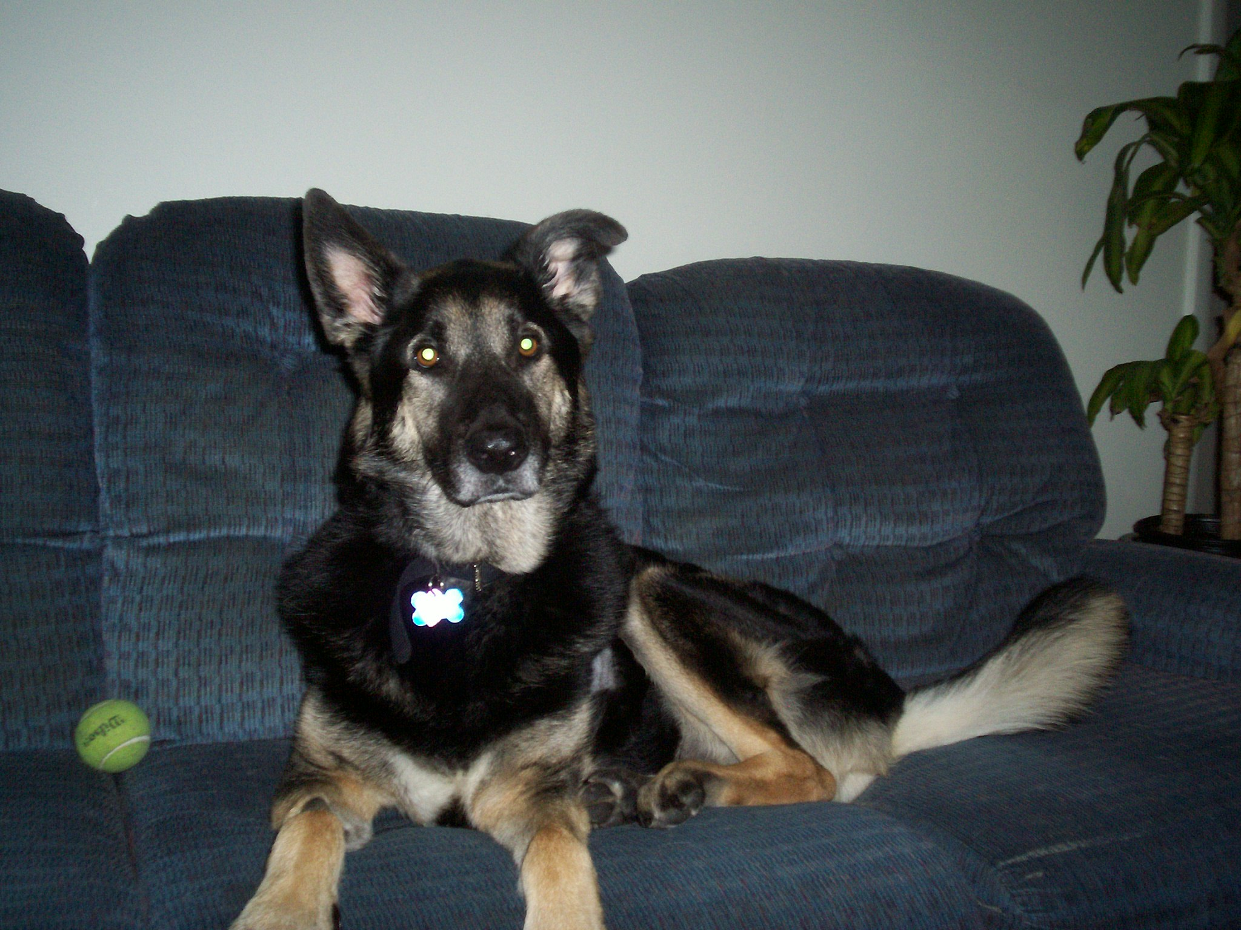

Ozzie is my 6 year old German Shepard that has had a rough month. It was discovered that Ozzie had fluid in his heart when we brought him to Tufts V.E.T.S. on St. Patrick’s Day. The doctors aren’t sure what caused the fluid but as of yet they have not discovered cancer or heart failure. It cost $2,300 for them to remove the fluid at the time.
On a follow up appointment, April 6th we learned the fluid is back. There is a procedure that will help Ozzie live a long life but that is an additional $3,000. The doctor can make a hole in the sack that covers the heart and the fluid will then leak into the chest cavity and become waste. Ozzie is a very healthy dog otherwise but if we don’t do this procedure, we will have to send him off to doggy heaven.
My 11 year old daughter is hoping we can save him. Please make Ozzie’s life as long as it can be. Any donation is great; even a dollar from you will help. We really need your help and Ozzie wants to stick around to be with his family for many years to come. Please help!

Donations can be sent to:
P.O. Box 621
Stoughton, MA 02072
Please call Kari if you would like to meet Ozzie or you have any questions
508-846-8684

